DATA-236 Sec 12 - Distributed Systems for Data Engineering HOMEWORK 5

Nandhakumar Apparsamy 018190003

GitHub - <https://github.com/Nandha951/DATA-236-HW4-Book-Store-CRUD> Integrate the REST API’s created in HW4 in your frontend using redux.

1. Redux and Axios (2 points)axis
   * Use Axios to make the API calls.

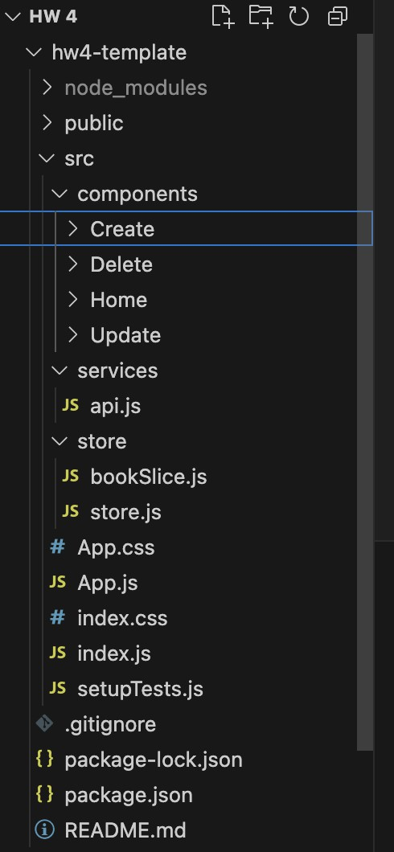

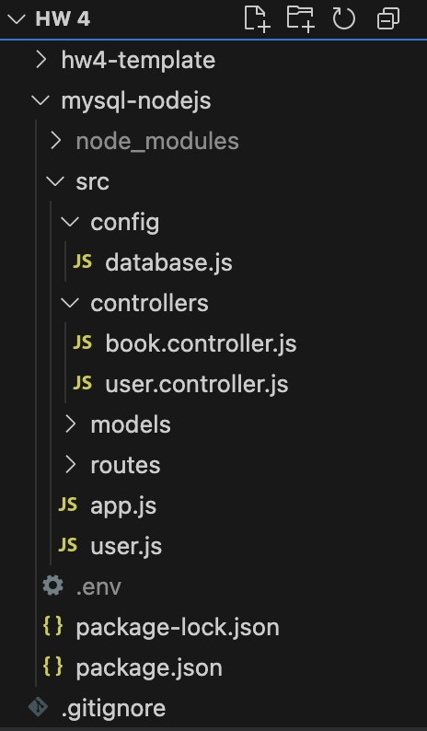

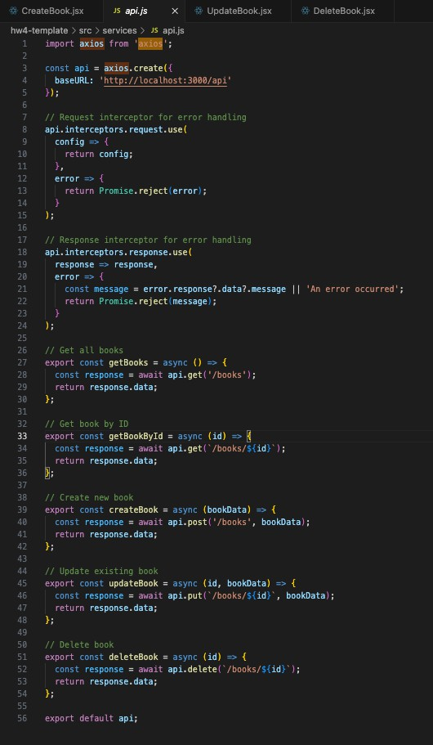

* Use redux to manage the state of the application. Make sure to make necessary constants, actions, reducers, and store and include screenshots of code as well as output.

**NOTE: I have used Reduxjs Toolkit**

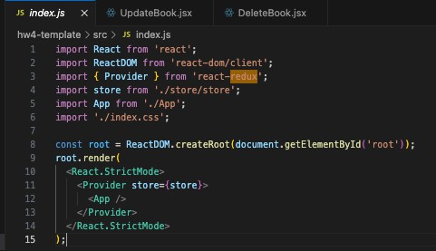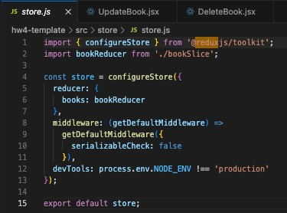

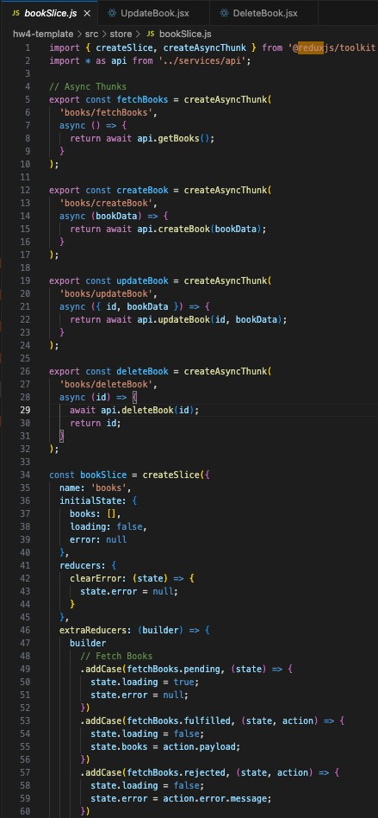

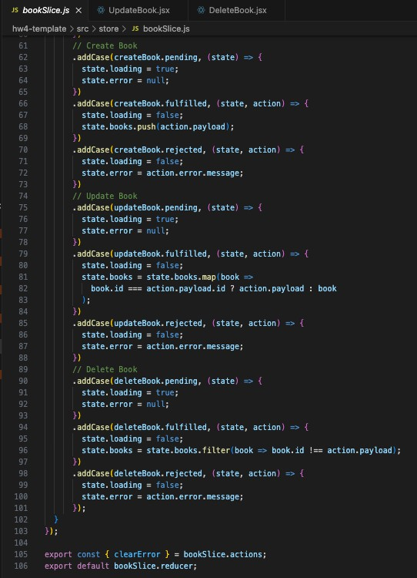

1. Home Screen (2 points)

* Integrate the Get API to fetch all books and display them on the home screen.

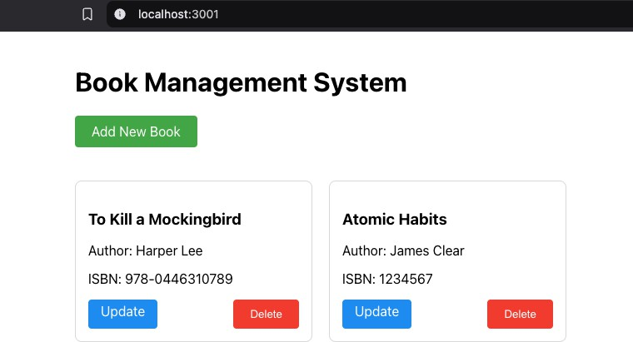

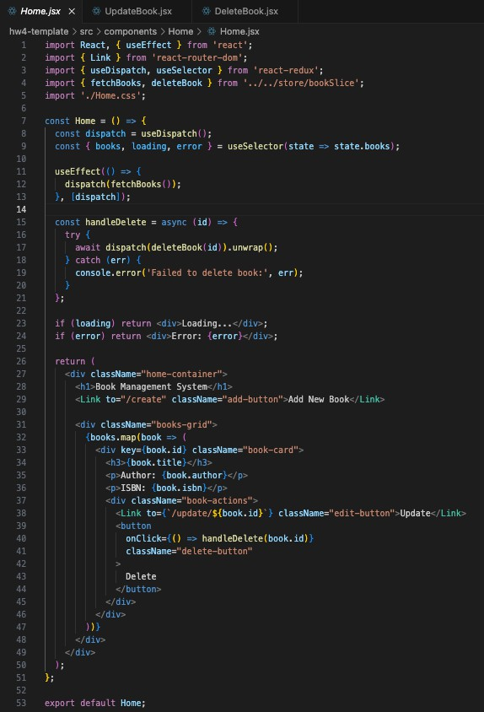

1. Create Screen (2 points)

* 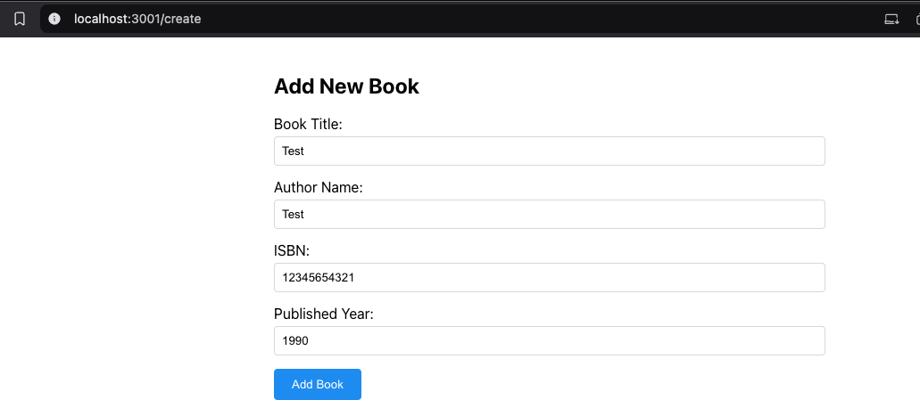Integrate the Post API to create a new book and display the updated results on the home Screen.

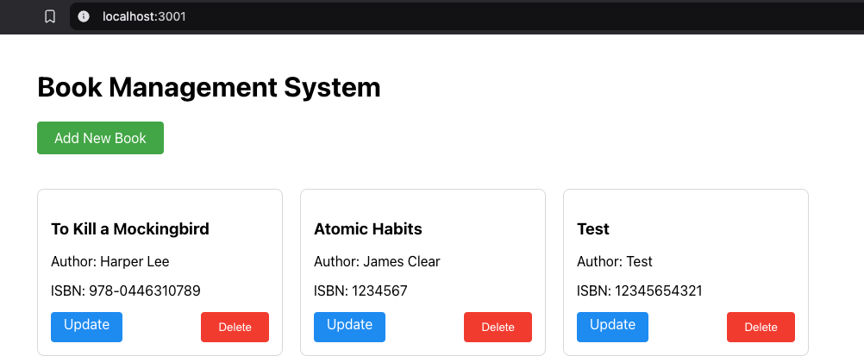

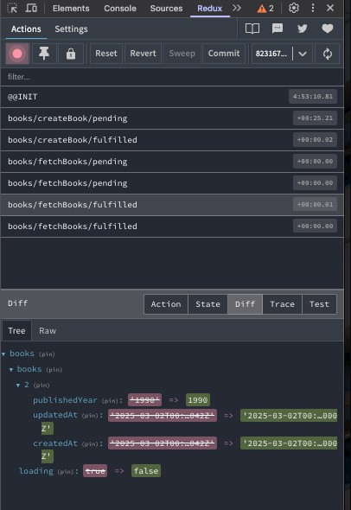

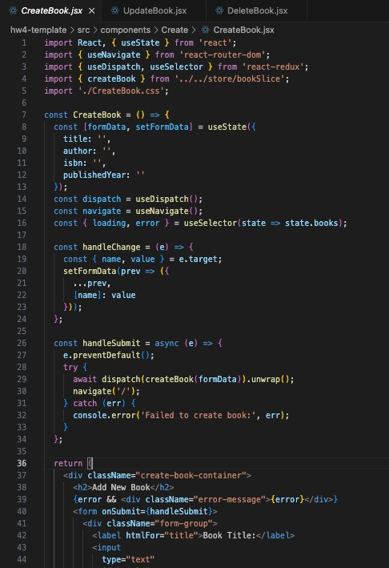

1. Update Screen (2 points)

* Integrate the Put API to update an existing book and display the updated results on the home screen.

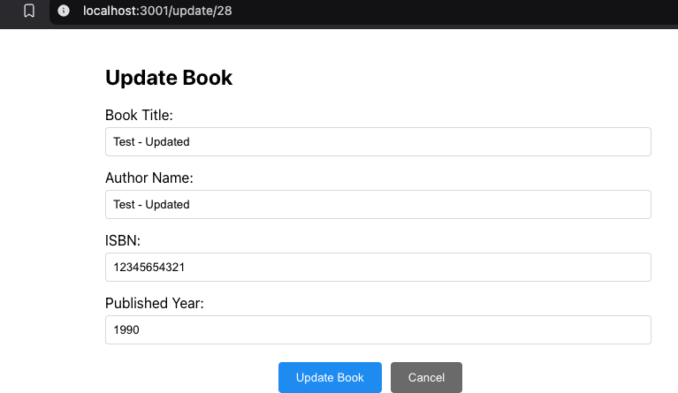

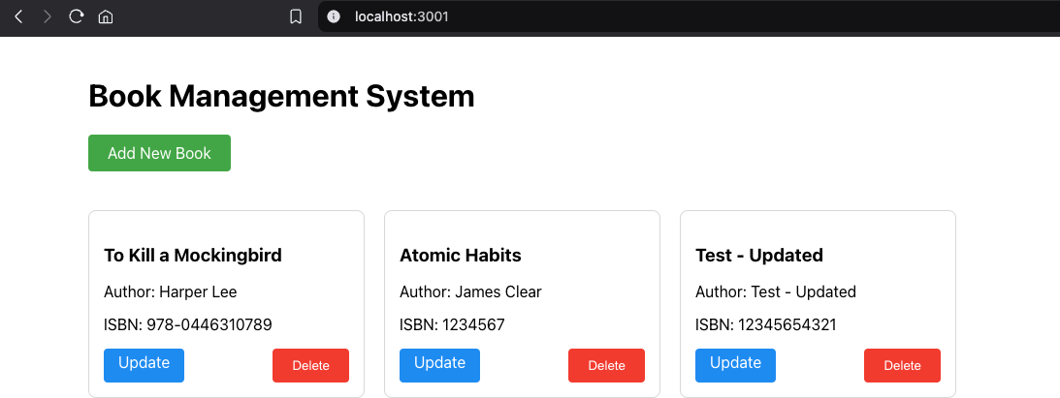

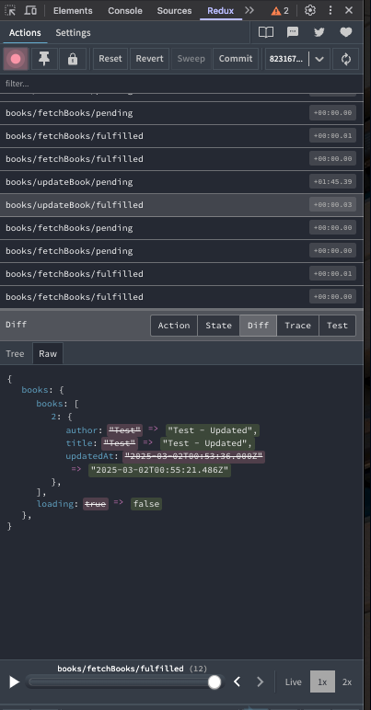

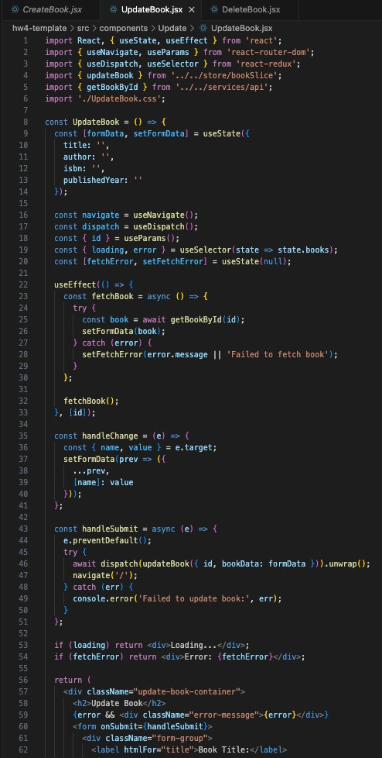

1. Delete Screen (2 points)

* 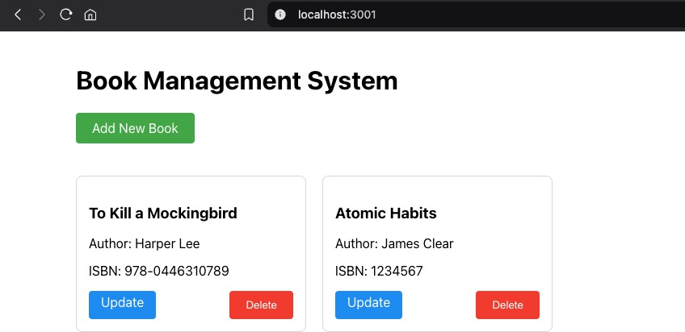Integrate the Delete API to delete an existing book and display the updated results on the home screen.

